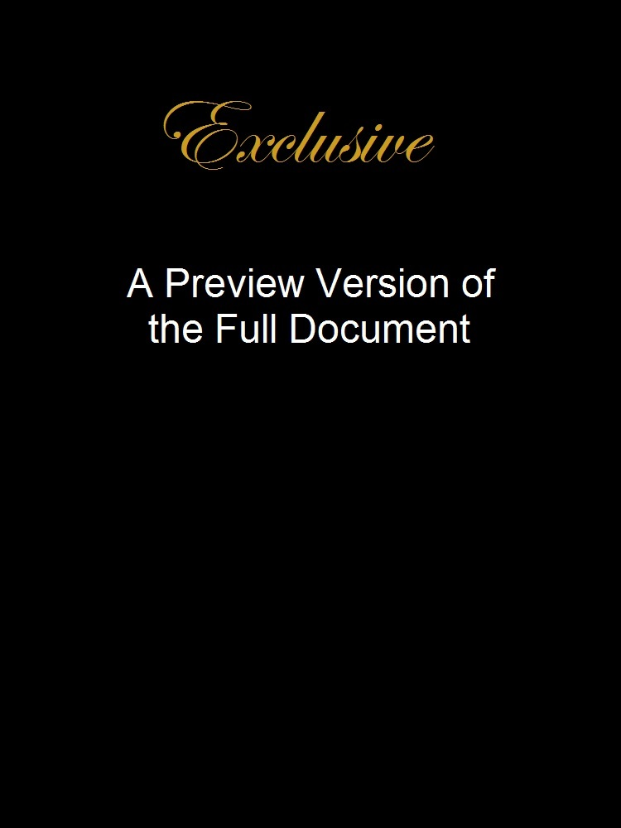

HR Strategic Planning Process

HR Strategic Planning
The overall purpose of strategic HR planning is to:
- Ensure adequate human resources to meet the strategic goals and operational plans of your organization - the right people with the right skills at the right time
- Keep up with social, economic, legislative and technological trends that impact on human resources in your area and in the sector
- Remain flexible so that your organization can manage change if the future is different than anticipated
Strategic HR planning predicts the future HR management needs of the organization after analyzing the organization's current human resources, the external labor market and the future HR environment that the organization will be operating in. The analysis of HR management issues external to the organization and developing scenarios about the future are what distinguishes strategic planning from operational planning. The basic questions to be answered for strategic planning are:
- Where are we going?
- How will we develop HR strategies to successfully get there, given the circumstances?
- What skill sets do we need?

The strategic HR planning process
The strategic HR planning process has four steps:
- Assessing the current HR capacity
- Forecasting HR requirements
- Gap analysis
- Developing HR strategies to support organizational strategies

Assessing current HR capacity
Based on the organization's strategic plan, the first step in the strategic HR planning process is to assess the current HR capacity of the organization. The knowledge, skills and abilities of your current staff need to be identified. This can be done by developing a skills inventory for each employee.
The skills inventory should go beyond the skills needed for the particular position. List all skills each employee has demonstrated. For example, recreational or volunteer activities may involve special skills that could be relevant to the organization. Education levels and certificates or additional training should also be included.
An employee's performance assessment form can be reviewed to determine if the person is ready and willing to take on more responsibility and to look at the employee's current development plans.

Forecasting HR requirements
The next step is to forecast HR needs for the future based on the strategic goals of the organization. Realistic forecasting of human resources involves estimating both demand and supply. Questions to be answered include:
- How many staff will be required to achieve the strategic goals of the organization?
- What jobs will need to be filled?
- What skill sets will people need?
When forecasting demands for HR, you must also assess the challenges that you will have in meeting your staffing need based on the external environment. To determine external impacts, you may want to consider some of the following factors:
- How does the current economy affect our work and our ability to attract new employees?
- How do current technological or cultural shifts impact the way we work and the skilled labor we require?
- What changes are occurring in the Canadian labour market?
- How is our community changing or expected to change in the near future?
To read more about the changing labor force and why it matters to non-profit employers, go to the Diversity at Work section of the HR Toolkit:
- Why diversity at work matters

Gap analysis
The next step is to determine the gap between where your organization wants to be in the future and where you are now. The gap analysis includes identifying the number of staff and the skills and abilities required in the future in comparison to the current situation. You should also look at all your organization's HR management practices to identify practices that could be improved or new practices needed to support the organization's capacity to move forward. Questions to be answered include:
THIS IS A PARTIAL DOCUMENT VIEW.

